# Installing Docker on Amazon Linux 2

The procedure to install Docker on AMI 2 (Amazon Linux 2) running on an EC2 instance is as follows:

1. Login into the remote AWS server using the ssh command or using putty:  
   $ ssh ec2-user@ec2-ip-address-dns-name-here
2. Apply pending updates using the yum command:  
   $ sudo yum update
3. Search for Docker package:  
   $ sudo yum search docker
4. Get version information:  
   $ sudo yum info docker

[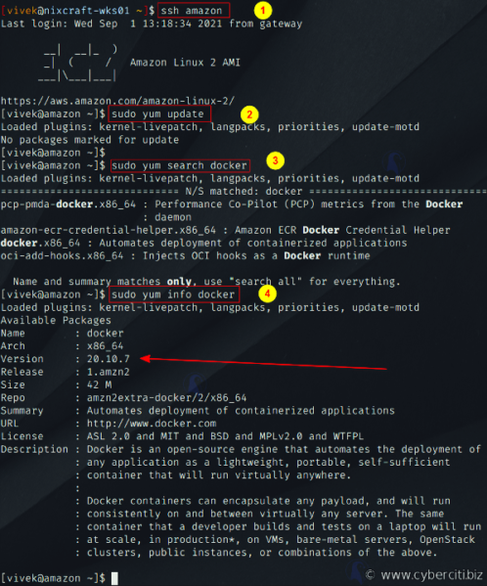](https://www.cyberciti.biz/media/new/faq/2021/09/Searching-for-Docker-package-on-Amazon-Linux-2-AMI.png)

Getting Docker version

1. Install docker, run:  
   $ sudo yum install docker

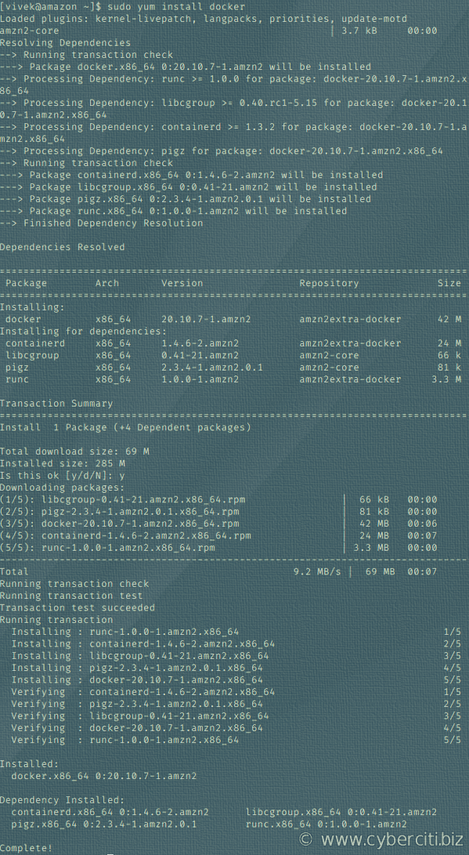

Amazon Linux 2: Install docker command

1. Add group membership for the default ec2-user so you can run all docker commands without using the sudo command:  
   $ sudo usermod -a -G docker ec2-user  
   $ id ec2-user  
   # Reload a Linux user's group assignments to docker w/o logout  
   $ newgrp docker
2. For docker-compose, try any one of the following commands:

*# Get pip3*

**sudo** **yum install** python3-pip

*# Then run any one of the following*

**sudo** pip3 **install** docker-compose *# with root access*

***OR***

pip3 **install** --user docker-compose *# without root access for security reasons*

***OR***

**wget** https:**//**github.com**/**docker**/**compose**/**releases**/**latest**/**download**/**docker-compose-$**(uname** -s**)**-$**(uname** -m**)**

**sudo** **mv** docker-compose-$**(uname** -s**)**-$**(uname** -m**)** **/**usr**/**local**/**bin**/**docker-compose

**sudo** **chmod** -v +x **/**usr**/**local**/**bin**/**docker-compose

[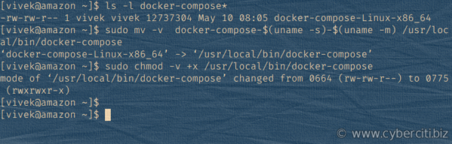](https://www.cyberciti.biz/media/new/faq/2021/09/Installing-docker-compose-on-Amazon-Linux-2-AMI.png)

How to install docker-compose in Amazon Linux

1. Enable docker service at AMI boot time:  
   $ sudo systemctl enable docker.service
2. Start the Docker service:  
   $ sudo systemctl start docker.service

# Verification

Now that both required software is installed, we need to make sure it is working. Hence, type the following commands.

### Finding status

Get the docker service status on your AMI instance, run:  
$ sudo systemctl status docker.service

**Outputs:**

● docker.service - Docker Application Container Engine

Loaded: loaded (/usr/lib/systemd/system/docker.service; enabled; vendor preset: disabled)

Active: active (running) since Wed 2021-09-08 05:03:52 EDT; 18s ago

Docs: https://docs.docker.com

Process: 3295 ExecStartPre=/usr/libexec/docker/docker-setup-runtimes.sh (code=exited, status=0/SUCCESS)

Process: 3289 ExecStartPre=/bin/mkdir -p /run/docker (code=exited, status=0/SUCCESS)

Main PID: 3312 (dockerd)

Tasks: 9

Memory: 39.9M

CGroup: /system.slice/docker.service

└─3312 /usr/bin/dockerd -H fd:// --containerd=/run/containerd/c...

Sep 08 05:03:51 amazon.example.local dockerd[3312]: time="2021-09-08T05:03...

Sep 08 05:03:51 amazon.example.local dockerd[3312]: time="2021-09-08T05:03...

Sep 08 05:03:51 amazon.example.local dockerd[3312]: time="2021-09-08T05:03...

Sep 08 05:03:51 amazon.example.local dockerd[3312]: time="2021-09-08T05:03...

Sep 08 05:03:52 amazon.example.local dockerd[3312]: time="2021-09-08T05:03...

Sep 08 05:03:52 amazon.example.local dockerd[3312]: time="2021-09-08T05:03...

Sep 08 05:03:52 amazon.example.local dockerd[3312]: time="2021-09-08T05:03...

Sep 08 05:03:52 amazon.example.local dockerd[3312]: time="2021-09-08T05:03...

Sep 08 05:03:52 amazon.example.local systemd[1]: Started Docker Applicatio...

Sep 08 05:03:52 amazon.example.local dockerd[3312]: time="2021-09-08T05:03...

Hint: Some lines were ellipsized, use -l to show in full.

### Getting docker version info on Amazon Linux

* The docker-compose is installed in the ‘/usr/local/bin’ directory and may not be on your PATH settings. To see current PATH settings run the echo command/printf command:

$ echo "$PATH"

* To add /usr/local/bin/ path to your bash startup file such as ~/.profile or ~/.bash_profile using the export command:

$ export PATH=$PATH:/usr/local/bin

* Another option for developers is to use the find command to locate the docker-compose file as follows:

$ sudo find / -name "docker-compose" -ls

See docker version:

$ docker version

Also verify that docker-compose install was a success on AMI 2 by running the following command:  
$ docker-compose version

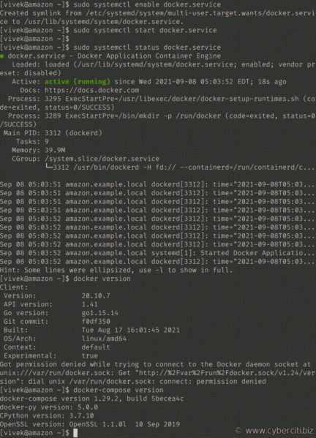

Getting docker version on AMI using the ssh client

### How to control docker service

Use the systemctl command as follows:

**sudo** systemctl start docker.service *#<-- start the service*

**sudo** systemctl stop docker.service *#<-- stop the service*

**sudo** systemctl restart docker.service *#<-- restart the service*

**sudo** systemctl status docker.service *#<-- get the service status*

# Creating your first Docker project

Make a new project folder using the mkdir command and cd into it using the cd command. For instance:  
$ mkdir static-website-1  
$ cd static-website-1

Use the echo command as follows to create a new index.html for our project:

$ echo 'Docker Training Apache static site' > index.html

Make a new Dockerfile using a text editor such as nano command or vim command:  
$ vim Dockerfile

Append the following config for your Amazon Linux container:

FROM rockylinux/rockylinux:latest

MAINTAINER DevOpsTrainer

LABEL Remarks="Linux test image for installing static webpage with Apache2"

*# Install apache2 with less*

RUN yum -y update && \

yum -y install httpd && \

yum clean all

*# Sample index.html for test*

COPY index.html /var/www/html/index.html

*# Port and set entry point for container*

EXPOSE 80

ENTRYPOINT /usr/sbin/httpd -DFOREGROUND

Build docker:  
$ sudo docker build -t staticsite01 .

**Outputs:**

Sending build context to Docker daemon 3.072kB

Step 1/7 : FROM rockylinux/rockylinux:latest

latest: Pulling from rockylinux/rockylinux

ecce7a433753: Pull complete

Digest: sha256:98dcf3fbe75741058c16ece621f5917e0ff52d9333073e6389c5de8efaa3d5c4

Status: Downloaded newer image for rockylinux/rockylinux:latest

---> 86f02aa837b3

Step 2/7 : MAINTAINER nixCraft

---> Running in 7f4f35c8d95a

Removing intermediate container 7f4f35c8d95a

---> e40cd8411b69

Step 3/7 : LABEL Remarks**=**"CentOS 8 test image for installing ng with Apache2"

---> Running in 31bf348db2fb

Removing intermediate container 31bf348db2fb

---> 28accfe0f9ff

Step 4/7 : RUN yum -y update && yum -y install httpd && yum clean all

---> Running in f588730a294f

Rocky Linux 8 - AppStream 6.2 MB/s | 10 MB 00:01

Rocky Linux 8 - BaseOS 6.7 MB/s | 7.7 MB 00:01

Rocky Linux 8 - Extras 59 kB/s | 12 kB 00:00

Dependencies resolved.

**================================================================================**

Package Arch Version Repo Size

**=**===============================================================================

Upgrading:

gzip x86_64 1.9-13.el8_5 baseos 166 k

libreport-filesystem x86_64 2.9.5-15.el8.rocky.6.3 baseos 20 k

openssl-libs x86_64 1:1.1.1k-6.el8_5 baseos 1.5 M

vim-minimal x86_64 2:8.0.1763-16.el8_5.13 baseos 574 k

zlib x86_64 1.2.11-18.el8_5 baseos 101 k

Installing dependencies:

openssl x86_64 1:1.1.1k-6.el8_5 baseos 708 k

Installing weak dependencies:

openssl-pkcs11 x86_64 0.4.10-2.el8 baseos 65 k

Transaction Summary

**=**===============================================================================

Install 2 Packages

Upgrade 5 Packages

Total download size: 3.1 M

.....

..

.....

rocky-logos-httpd-85.0-3.el8.noarch

Complete!

27 files removed

Removing intermediate container f588730a294f

---> c72a6a74580e

Step 5/7 : COPY index.html /var/www/html/index.html

---> bb05689ae9d3

Step 6/7 : EXPOSE 80

---> Running in dda665ce8a4a

Removing intermediate container dda665ce8a4a

---> 04f4b6d74635

Step 7/7 : ENTRYPOINT /usr/sbin/httpd -DFOREGROUND

---> Running in 2a9d3c85cbd7

Removing intermediate container 2a9d3c85cbd7

---> 51c5c08cf14d

Successfully built 51c5c08cf14d

Successfully tagged staticsite01:latest

### List images:

$ sudo docker images

REPOSITORY TAG IMAGE ID CREATED SIZE

staticsite01 latest 51c5c08cf14d 3 minutes ago 232MB

rockylinux/rockylinux latest 86f02aa837b3 6 weeks ago 205MB

### Run docker:

$ sudo docker run -d -p 80:80 --name staticsite01 staticsite01  
$ sudo docker ps  
$ sudo docker port staticsite01  
$ curl 127.0.0.1:80

[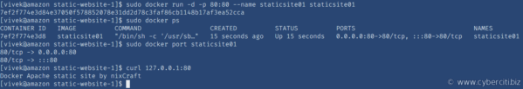](https://www.cyberciti.biz/media/new/faq/2021/09/Testing-Docker-with-Dockerfile-on-AMI.png)

## Summing up

That is all for now. You learned how to install Docker on AMI 2 and deploy Apache 2 as the Docker container for a static website. Use the following command to get an overview of available commands:  
$ docker help  
$ docker --help

For specific client examples please see the man page for the specific Docker command using the man command. For instance:  
$ man docker-build  
$ man docker-run